Dice Game Results Lost and Found

Team Results:

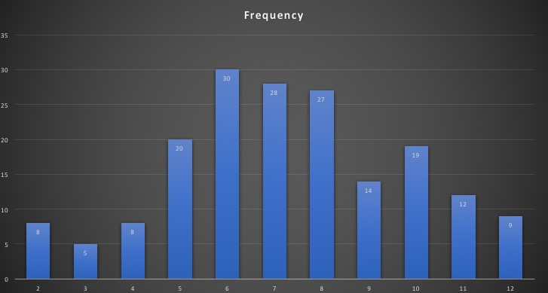

Low on edges, rises towards middle.

Most Similar:

Nick and Maddie

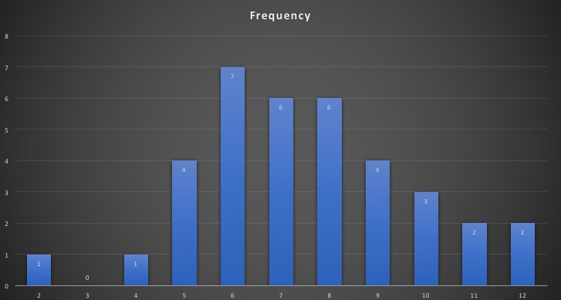

Low on edges, rises near middle. Similar to bell curve.

Most Different:

Pablo and Haley

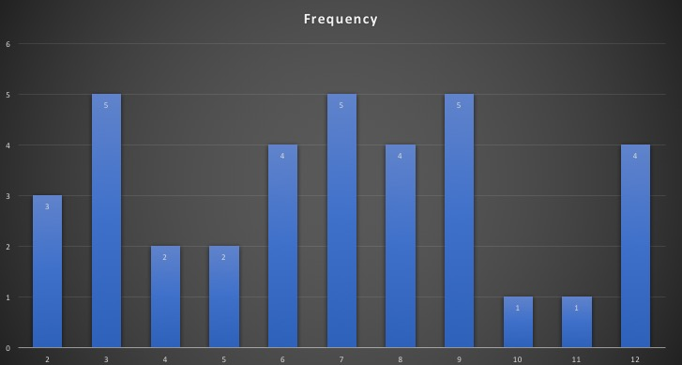

Peaks on edges, dips near middle. Only group to have rolled 3’s.